APPLECROSS SENIOR HIGH SCHOOL 3A/3B BIOLOGY
CELLULAR PROCESSES TEST
DO NOT WRITE ON THIS PAPER

1. Of the following list of substances that can enter a cell, match the order with the correct mechanism by which they would enter cells:
oxygen, water, sodium ions, potassium ions, a bacterium. (Note that sodium ions are more concentrated outside cells than inside; potassium ions are more concentrated inside cells than outside.)
a) endocytosis, active transport, active transport, facilitated diffusion, exocytosis
b) simple diffusion, osmosis, facilitated diffusion, active transport, exocytosis
c) simple diffusion, osmosis, facilitated diffusion, active transport, endocytosis
d) passive transport, osmosis, simple diffusion, facilitated diffusion, active transport

2. The chloroplast is the organelle responsible for photosynthesis in eukaryotic cells. In chloroplasts
a) the light independent reactions require water as the initial reactant.
b) the light independent reactions occur in the inner membrane area.
c) the final product of the light reaction is glucose.
d) the light reactions occur in the grana.

3. The plasma membrane of a cell
a) is inﬂexible due to the presence of protein molecules.
b) allows substances to pass through only by active transport.
c) contains cholesterol molecules which can act as cell receptors.
d) is relatively impermeable to large water-soluble molecules due to the presence of the bilipid layer.

4. The protozoan Kentrophoros carries a dense coat of bacteria on its surface. Kentrophoros engulfs these bacteria by bending its cell surface around them. This process is known as
a) exocytosis.
b) apoptosis.
c) pinocytosis.
d) phagocytosis

5. According to the fluid mosaic model of the plasma membrane, proteins are
a) spread out in a continuous layer over both membrane surfaces
b) located in the hydrophilic area of the membrane
c) oriented in a random manner throughout the membrane
d) embedded in the lipid bilayers.

6. Amylase is an enzyme which catalyses the breakdown of starch. As the temperature rises the action of this enzyme will
a) increase until the enzyme begins to denature
b) decrease until the substrate begins to denature
c) increase until the enzyme is used up
d) decrease until the substrate reaches a maximum concentration
7. What is the most important difference between active transport and passive transport.
a) Active transport uses carrier proteins and passive transport does not.
b) Active transport always occurs through membranes and passive transport does not
c) Passive transport uses energy and active transport does not.
d) Passive transport moves molecules with a concentration gradient and active transport does not.

8. The enzyme lactase digests lactose.
lactase
lactose glucose + galactose

Two test tubes where set up using 5 mL of lactose syrup and 0.5 mL of lactase. Test tube one was incubated at 37°C, while test tube two was incubated at 15°C. Both tubes were incubated for 10 minutes.
At the end of 10 minutes, the amount of glucose produced in test tube two when compared to test tube
one would be
a) lower as the enzyme’s active site would have denatured at this temperature.
b) equal as lowering the temperature does not affect digestion of lactose.
c) lower as there would be fewer collisions between the substrate and the enzyme.
d) equal as the two test tubes contained the same amount of lactose and lactase enzyme.

9. Active yeast cells were added to a container of nutrient solution and the container was then sealed. Levels of oxygen, carbon dioxide and glucose were then measured continuously over a period of time. X and Y represent time intervals when two different types of respiration are occurring.
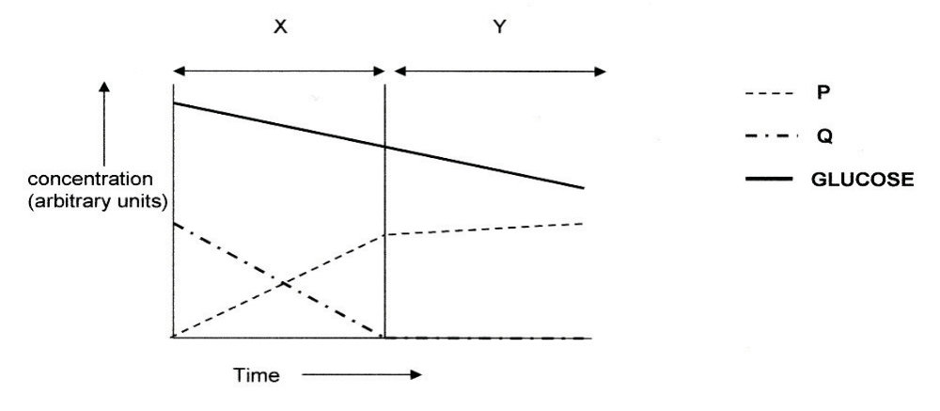
For the time interval shown in the graph, choose the correct representation of P, Q, X
and Y from the alternatives provided in the table.
 | P | Q | X | Y
A | carbon dioxide | oxygen | anaerobic respiration | aerobic respiration
B | oxygen | carbon dioxide | aerobic respiration | anaerobic respiration
C | carbon dioxide | oxygen | aerobic respiration | anaerobic respiration
D | oxygen | carbon dioxide | anaerobic respiration | aerobic respiration

10 A student was asked to identify differences between the overall processes of photosynthesis and aerobic respiration in eukaryotic cells. The student prepared the table below to outline the differences.
The only correct comparison listed by the student is
 | Photosynthesis | Aerobic respiration
A | Uses ATP as an energy source | Produces ATP as an energy source
B | All stages occur within chloroplasts | All stages occur within mitochondria
C | Produces oxygen | Does not use oxygen
D | Uses water as a reactant in the first stage | Forms water as a product in the final stage

11. Substance A is converted to substance B in a metabolic reaction. Which statement best describes the role of an enzyme during this reaction?
a) It adjusts the pH of the reaction medium.
b) It provides energy to carry out the reaction.
c) It dissolves substance A in the reaction medium.
d) It speeds up the reaction without being consumed

12. Photosynthesis and cellular respiration are two major processes of carbon cycling in living
organisms. Which statement correctly describes one similarity between photosynthesis and cellular respiration?
a) Both occur in animal and plant cells.
b) Both include reactions that transform energy.
c) Both convert light energy into chemical energy.
d) Both synthesize organic molecules as end products.

13. A scientist observes that, when the temperature of the environment surrounding an enzyme is changed, the rate the enzyme catalyzes a reaction greatly decreases. Which statement
best describes how a change in temperature can affect an enzyme?
a) A temperature change can cause the enzyme to change its shape.
b) A temperature change can remove energy necessary to activate an enzyme.
c) A temperature change can add new molecules to the structure of the enzyme.
d) A temperature change can cause an enzyme to react with a different substrate

14. Which of the following statements is incorrect?
a) Anaerobic respiration uses oxygen to release energy from food.
b) Aerobic respiration releases oxygen from food during oxidation.
c) Aerobic respiration converts food to carbon dioxide and water.
d) Anaerobic respiration releases energy from food without using oxygen.

15 Which one of the following would be acceptable evidence that some form of respiration
was taking place in a living tissue
a) oxygen being taken up
b) oxygen being given out
c) water vapour being produced
d) CO₂ being used up

16. A protein-digesting enzyme when mixed with starch solution would
a) have no action
b) produce amino acids
c) produce glucose
d) digest the starch?

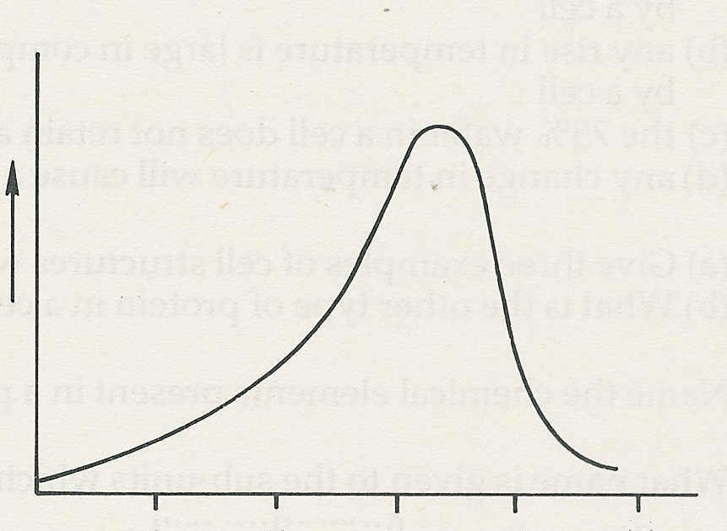
17. The graph shows the rate of an enzyme reaction at different levels of acidity or alkalinity (pH). From the graph, what is the optimum pH for this enzyme?
a) pH 2
b) pH 7 .
c) pH 10
d) none of these

rate of reaction

pH 2 4 6 8 10
18. The process of aerobic respiration requires
a) A food source, oxygen, enzymes, a blood supply
b) A food source, carbon dioxide, enzymes
c) Oxygen, enzymes, sunlight
d) A food source, oxygen, enzymes

19. Which of these statements is most accurate?
In bright sunlight a green plant will be
a) photosynthesising only
b) respiring only
c) photosynthesising and respiring
d) taking in oxygen and giving out CO₂

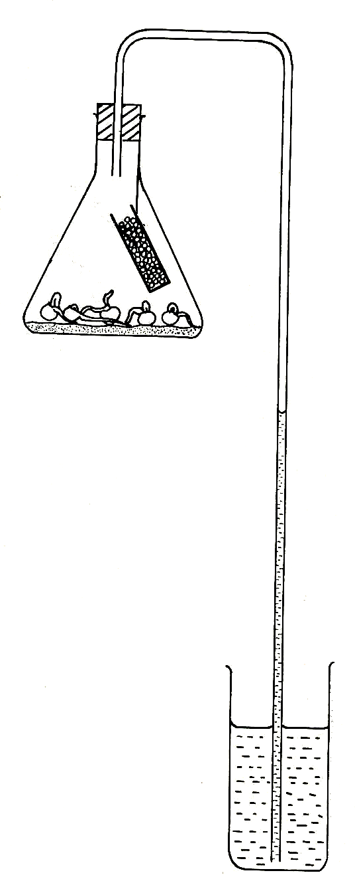
20. A student sets up this experiment to investigate whether germinating seeds take up oxygen. The experiment is inadequately designed because
a) there is no control experiment
b) there are not enough seeds soda lime
c) there is no temperature control
d) the volume of CO₂ taken up will be the same
as the volume of CO₂ given out

germinating
seeds

WRITTEN SECTION: WRITE YOUR ANSWERS IN THE SPACES PROVIDED

Name:___________________________________________ Mark: Multiple Choice /20
Written Section /30
TOTAL /50

1. Refer to the diagram below.

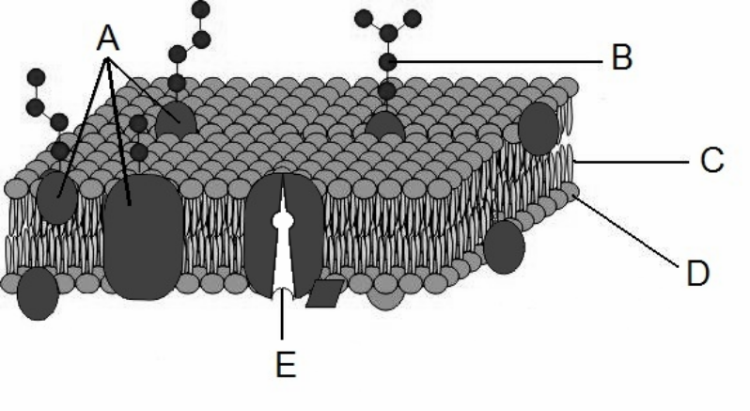

a) Name the biological molecules which make up the following:
A _______________________________ C _______________________________
D_______________________________ (3 marks)
b) In class you carried out a practical involving the effect of several different substances on pieces of beetroot. Explain why the solutions below caused the leakage of the purple colour. (2 marks)
(i) Detergent _____________________________________________________________________
________________________________________________________________________________
(ii) Boiled water__________________________________________________________________
________________________________________________________________________________
c) Structures such as the one labeled E enable molecules to pass through the membrane that would otherwise be unable to do so.
(i) What is the name of structure E __________________________________ (1 mark)
(ii) Describe one way this process can occur.
________________________________________________________________________________
________________________________________________________________________________
________________________________________________________________________________
________________________________________________________________________ (3 marks)

2. There are two stages in cell respiration, the first stage only producing a small amount of energy.
a) Name the first stage of cell respiration. __________________________________ (1mark)

b) Where does this reaction occur in the cell? ________________________________ (1mark)

c) Cells which require a lot of energy from respiration have a large number of mitochondria. These are able to produce large numbers of the molecule ATP. List three ways in which organisms might use the energy stored in ATP.
________________________________________________________________________________
________________________________________________________________________________
___________________________________________________________________________(3 marks)
d) Mitochondria have many closely folded internal membranes called cristae. Explain what advantage this gives.________________________________________________________________________________
___________________________________________________________________________(2 marks)
e) Apart from respiration, name one other reaction which produces ATP.
____________________________________________________________________________(1mark))

f) In which organelle would this reaction take place in a cell? ___________________________(1mark)

3. The following question refers to the diagram below, which shows the events that occur during a
reaction involving an enzyme.

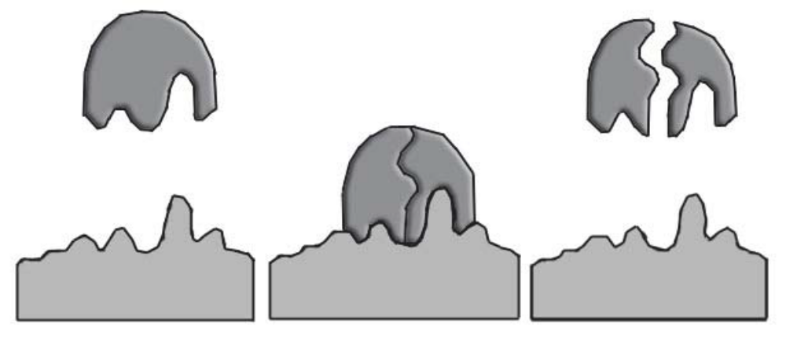
Substrate products

B

A

enzyme
Complete the following questions using the information in the diagram above.

a) Name the region indicated by A.
_____________________________________________________________________________(1 mark)
b) Name structure B.
_____________________________________________________________________________(1 mark)
c) Is this reaction more like photosynthesis or respiration? Explain why.
________________________________________________________________________________
________________________________________________________________________ (2 marks)
d) Explain how enzymes increase the speed of a chemical reaction in the body.
________________________________________________________________________________
_________________________________________________________________________ (1 marks)
e) The above diagram represents the lock and key model of enzyme action. What is the other model and how does it differ?
________________________________________________________________________________
_______________________________________________________________________________
________________________________________________________________________ (2 marks)

4. Some substances cannot pass directly through a plasma membrane but must use vesicular transport instead. Outline the different types of vesicular transport using a diagram if possible.

